SKIL 19 : INVERT SUBJECT AND VERB WITH COMPARISON

Penukaran pada ‘subject’ dan ‘verb’ dapat muncul pada clausa setelah ‘comparison.’ Penukaran tersebyt bersifat ‘opsional.’ Perhatikan contoh berikut
- My sister spends more hours in the office than John
- My sister spends more hours in the office than John does
- My sister spends more hours in the office than does John

Pada kalimat-kalimat diatas ‘comparison’ yang digunakan adalah ’more … … than.’ Berikut adalah contoh soal TOEFL :

The result of the current experiment appear to be more consistent than ____ the results of any previous tests.
- Them
- Were
- They were
- Were they
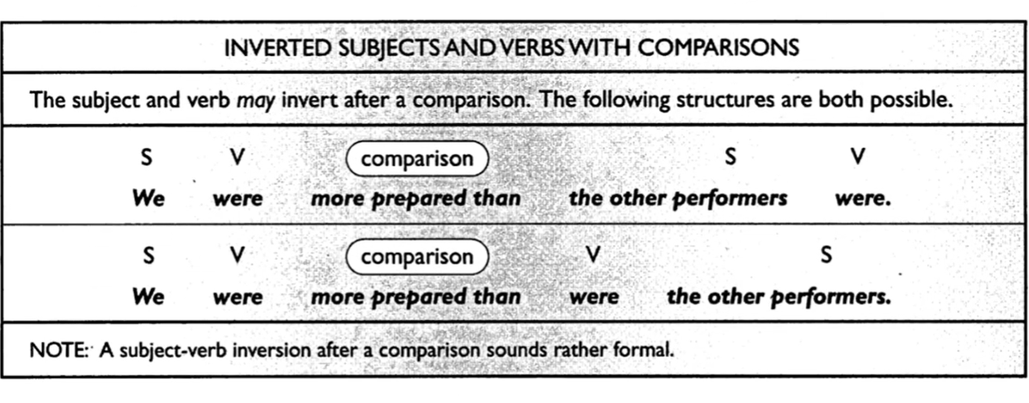
Exercise
- This candidate has received more votes than has any other candidate in previous years
- Correct
- Incorrect
- Obviously we were much more impressed with the performance than did the other members of the audience
- Correct
- Incorrect
- The film that we saw last night at the festival was far better than any of the other films
- Correct
- Incorrect
- The vegetables at the market this morning were far refresher than were those at the market yesterday
- Correct
- Incorrect
- I’m afraid that is the condition of these tires as bad as the condition of the others
- Correct
- Incorrect
- We firmly believed that our team could achieve a much faster time than any of the others
- Correct
- Incorrect
- This apple pie is not as good as the last one that you made
- Correct
- Incorrect
- On the fishing trip, Bobby caught twice as many fish as anyone else did
- Correct
- Incorrect
- The final speaker gave us more details than had any of the previous speaker
- Correct
- Incorrect
- Do you know why does he need to sleep so many more hours than do the others?
- Correct
- Incorrect

EVALUASI SKILL 15 – 19

Part A. Choose ‘correct’ or ‘incorrect’ for the following statements
- The town council is not sure why have they land developers changed their plans
- Correct
- Incorrect
- Never in the world I believed that this would happen
- Correct
- Incorrect
- The day might have been a little more enjoyable had the sun been out a little more
- Correct
- Incorrect
- Only once did the judge take the defense lawyer’s suggestion
- Correct
- Incorrect
- Down the Hall to the left the offices are that need to be painted
- Correct
- Incorrect
- Did the scientist explain what he put in the beaker?
- Correct
- Incorrect
- Hardly ever it snows in this section of the country
- Correct
- Incorrect
- Elijah scored more points In yesterday’s basketball final than had any other player in history
- Correct
- Incorrect
- In the state of California, earthquakes occur regularly
- Correct
- Incorrect
- He should ever call again, please tell him that I am not at home
- Correct
- Incorrect
Part B. Choose A, B, C, or D for the following questions
- Rarely ____ located near city lights or at lower elevations
- Observatories are
- Are
- In the observatories
- Are observatories
- There are Geographic, Economic, and cultural reasons why ___ around the world
- Diets differ
- Do diets differ
- Are diets different
- To differ a diet
- Were ___ millions of dollars each year replenishing eroding beaches, the coastline would be changing even more rapidly
- The U.S. Army Corps of Engineers not spending
- The U.S. Army Corps of Engineers not spend
- The U.S. Army Corps of Engineers does not spend
- Not spending The U.S. Army Corps of Engineers
- Nowhere ___ more skewed than in the auto industry
- That retail trade figures
- Retail trade figures are
- Are retail trade figures
- Retail trade figures
- New York City’s Central Park is nearly twice as large ___ second smallest country, Monaco
- As
- Is the
- As is
- As is the
- Potassium has a valence of positive one because it usually loses one electron when ___ with other elements
- Does it combine
- It combines
- In combining
- Combination
- The Economic background of labor legislation will not be mentioned in this course, ___ be treated
- Trade unionism will not
- Nor trade unionism will
- Nor will trade unionism
- Neither trade unionism will
- ___ test positive for antibiotics when tanker trucks arrive at a milk processing plant, according to the federal law, the entire truckload must be discarded
- Should milk
- If milk
- If milk is
- Milk should
- Located behind ___ the two lacrimal glands.
- Each eyelid
- Is each eyelid
- Each eyelid are
- Each eyelid which is
- Only for a short period of time ___ run at top speed
- Cheetahs
- Do cheetahs
- That a cheetahs can
- Can

